## 

**HACETTEPE UNIVERSITY**

**ENGINEERING FACULTY**

**DEPARTMENT OF COMPUTER ENGINEERING**

**BBM 425**

**INTERNSHIP REPORT**

**Mehmet Taha USTA**

**21527472**

**Tosyalı Toyo Çelik A.Ş**

**24/06/2019 – 05/08/2019**

**30 Works Days**

**TABLE OF CONTENTS**

**1 Introduction** **2**

**2 Company Information** **2**

2.1 About the company 2

2.2 About your department 4

2.3 About the hardware and software systems 6

**3 Work Done** **8**

3.1 Seminars 8

3.2 Project 8

**4 Performance and Outcomes** **10**

4.1 Applying Knowledge and Skills Learned at Hacettepe 10

4.2 Solving Engineering Problems 10

4.3 Teamwork 10

4.4 Multi-Disciplinary Work 10

4.5 Professional and Ethical Issues 10

4.6 Impact of Engineering Solutions 10

4.7 Locating Sources and Self-Learning 10

4.8  Using New Tools and Technologies 11

**5 Conclusions** **11**

**References** **11**

# 

# **1 Introduction**

The name of my internship company was Tosyalı Toyo Çelik A.Ş and my department was IT (information technology). The main focus of the company is to produce a wide range of products from packaging industry to electrical appliances, IT products to construction sector, from household appliances to automotive.

This internship was a software and hardware internship. Main focuses of the internship were writing a common interface to the phone and computer with SAPUI5 SDK, ABAP programming, creating user interface using XML views, workflow within the factory, Javascript programming. At the end of internship, SAPUI5 SDK, ABAP programming, XML views, Javascript programming, C programming, workflow within the factory, Occupational health and safety, Pneumatics were understood.

# **2 Company Information**

# **2.1 About the company**

# tosyali toyo çelik a.ş. ile ilgili görsel sonucu

Figure 1: Company Logo

# Tosyalı Toyo Factory

# The cooperation agreement between Tosyalı Holding, the leading Turkish private sector producer of flat steel and steel piping, and Toyo Kohan, a leading company in steel products produced with advanced technology of Japan and the world, was signed in February 2012.

# Tosyalı-Toyo Çelik A.Ş. is Turkey’s first advanced technology and high added-value flat steel producer, and its foundations were laid in January 2015 as a result of about three years of preparation work.

## The facility was established in a space of 250,000 square meters in the Osmaniye Organized Zone with a total investment cost of $650 million, and it began trial production in December 2016 and immediately after pasted to serial production.

## A significant portion of the products imported with this investment, which aims to remove Turkey’s external dependence in advance-technology steel products, is met domestically and contributes to the reduction of the current deficit.

## Tin, galvanized sheet, painted sheet, cold rolled sheet, and acid-oil roll production is completed at the facilities where about 800 people work with a rolling capacity of 1.2 million tons. The products used in a wide array from the packaging industry to electrical home appliances, from information products to the construction sector, from appliances to automotive don’t meet the needs of just Turkey but of a wide geography stretching from Europe to the Caucasus and from the Middle East to North Africa.

## About Toyo Kohan

## Toyo Kohan was founded as the first tin plate producer in Japan in 1934. It is in the position of the number-one company that is a pioneer in Japan and has the most advanced production technologies in the world in electro-galvanized, nickel coating, surface-processed steel, chromium coating, and film-coated steel. The turnover of Toyo Kohan, which has investments in Japan, Malaysia, and China, was $1.5 billion in 2017. The Company employs about 1,300 people.

## **2.2 About my department**

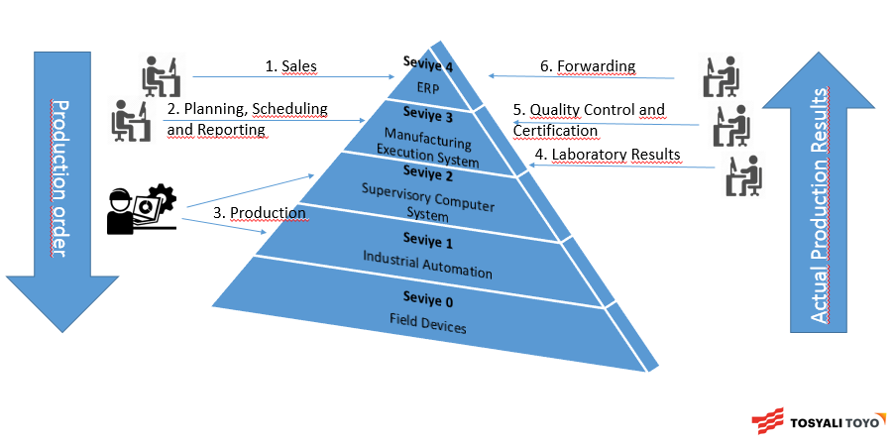

My position in the department was level 3-2(Planning, Scheduling and Reporting)

● Main topics and products

1. Monitoring of all factory data from the office

2. Production optimization as a result of data analysis

3. Analysis of production costs and questioning of increasing costs

4. Preventing human errors by automating energy consumption reports

5. Enables machine learning and modeling through stored data

6. Establishing KPIs of production lines and enabling instant monitoring

7. To be able to conduct statistical studies by storing long-term historical data

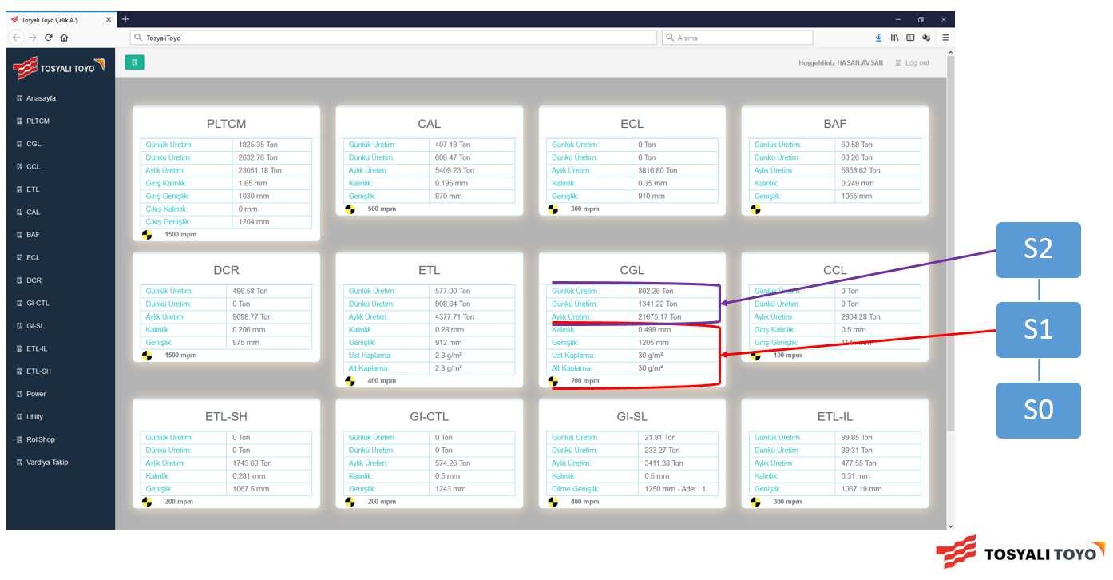

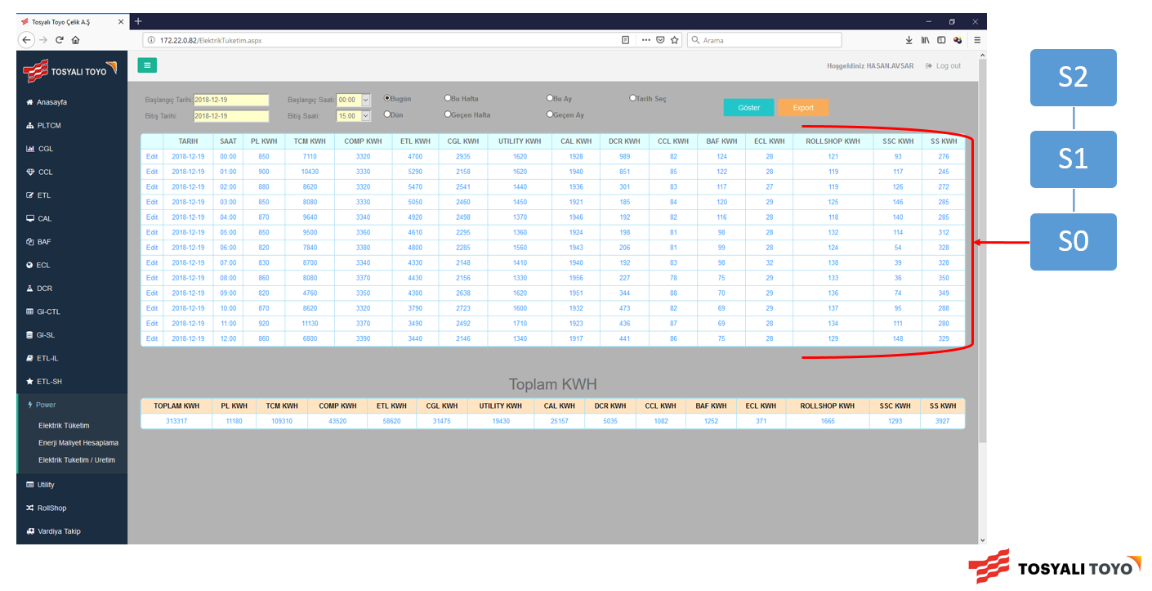

## 

## **2.3 About the hardware and software systems**

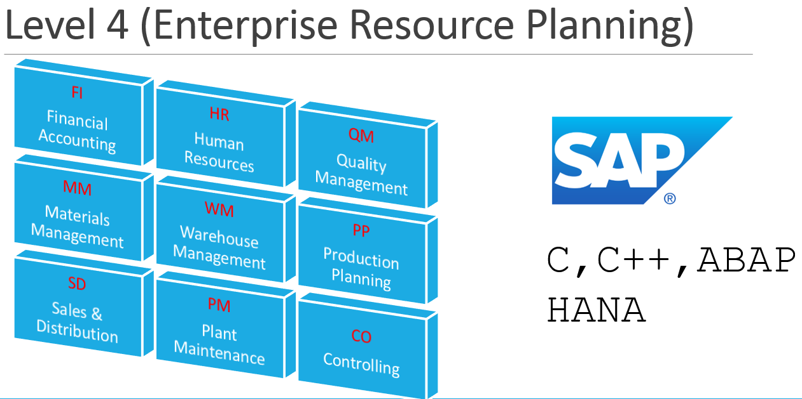

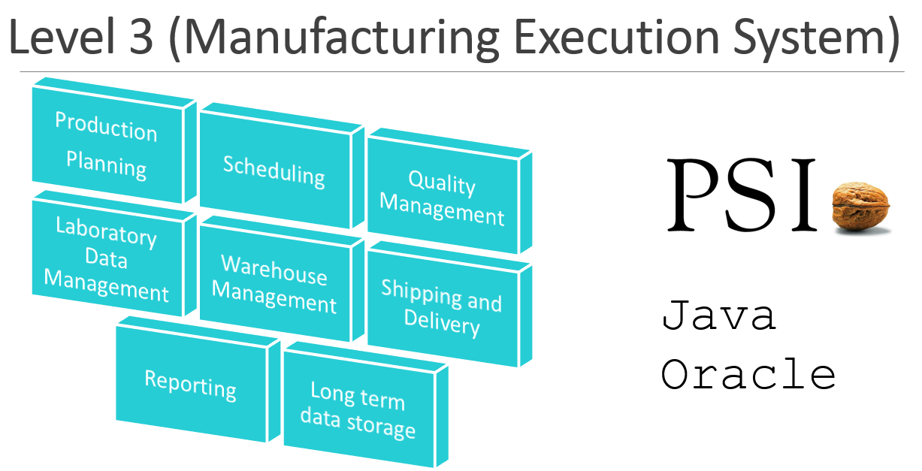

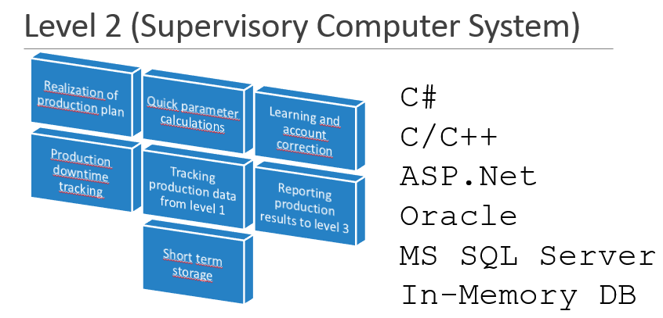

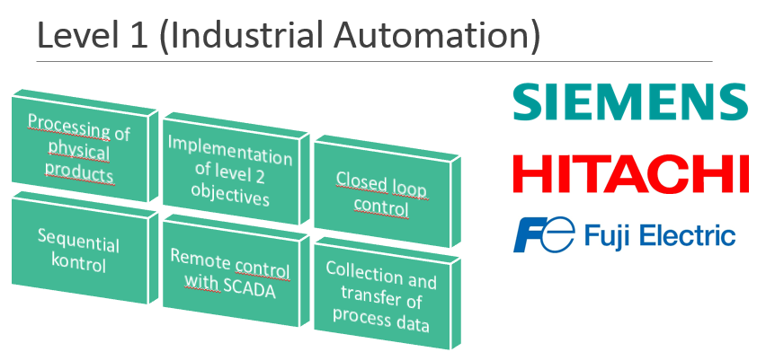

**2.4 About supervisor**

* İlker Satmaz,
* Büyük Tüysüz District. Kudamatsu Street No:4, 80950 Toprakkale/Osmaniye
* 0536 893 3767,
* ilker.satmaz @ tosyalitoyo.com.tr
* 9 Eylül University Computer Engineering

# **3 Work Done**

## **3.1 Seminars**

## I attended to a lot of courses related to software engineering, occupational health and safety, programming techniques and on the use of tools and software within the factory.

In the seminar courses, c programming, how to ensure work safety in the factory, what should be done in case of emergency, working principles of the tools in the factory, how the work flow, training was given about the use of technological tools in the factory.

## **3.2 Project**

My main project task is to make DnD (drag and drop) using SAPUI5. This was to make it easier for employees to track changes made to large iron rolls and write applications running on the phone and on the computer. The importance of my project is to minimize the complexity and reduce the margin of error, thus saving time and manpower. My main motivation was improve myself by reflecting the knowledge I learned at school to my professional life and to adapt to my professional life. The project was made with eclipse SAPUI5 plugin on windows 10 operating system. We have decided that SAPUI5's own tools are insufficient for the dnd table. To solve this problem I downloaded an extra script file from the internet. I have created the necessary interface in front-end using xml.view. I provided a solution to the problem by using the Javascript file in the back-end.

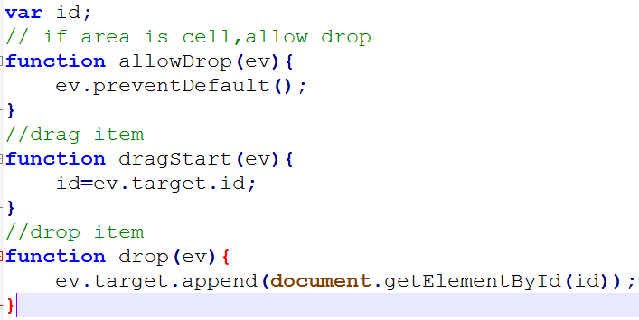

Figure 2: Simple Code

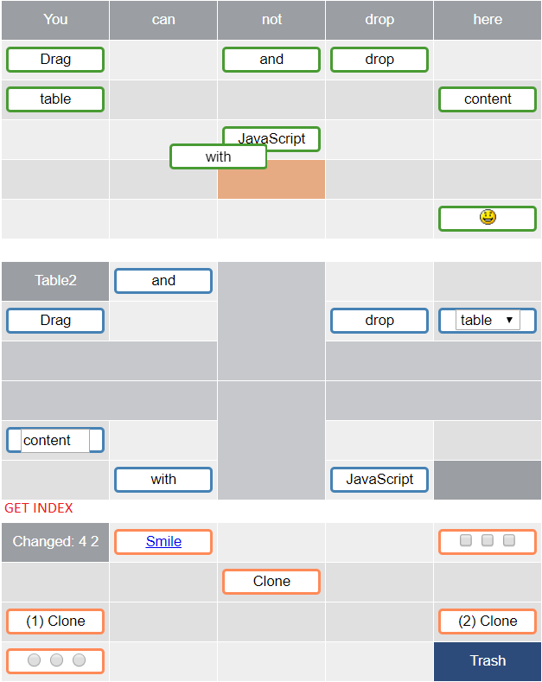

Figure 3: Final Version Of The Project

# 

# **4 Performance and Outcomes**

## **4.1 Applying Knowledge and Skills Learned at Hacettepe**

I used some skills and technologies which i learned in Hacettepe University. For example I was supposed to implement MVVM(Model–view–viewmodel) design pattern in the project, because I had already seen it in Software Engineering(BBM 382) I could easily implement it.

## **4.2 Solving Engineering Problems**

As I said in ’Applying Knowledge and Skills Learned at Hacettepe’. I also applied these techniques including design patterns and engineering methods.

**4.3 Teamwork**

I was not in a team while i was doing my internship . But i and other research-development workers and interns did conversations.So we improved each other.

**4.4 Multi-Disciplinary Work**

Tosyali Toyo Celik A.S. has to apply multi-disciplinary work in their every project. For example management engineers work there. Also there are many electric/electronic ,machine engineers, computer engineers.

## **4.5 Professional and Ethical Issues**

## **4.6 Impact of Engineering Solutions**

During the internship, during the software development period, I learned that there are many factors besides coding and the most important factor is the harmony of the departments within each other.

## **4.7 Locating Sources and Self-Learning**

When I was coding the project, the resources I used in the internship were libraries, documents, youtube and github projects.

## **4.8 Using New Tools and Technologies**

The new technologies I use during my internship are SAPUI5, ABAP, Javascript. To find out, I reviewed the documents on the internet. Advantages make things easier. The downside to SAPUI5 is that it is not widely used and there are no easy solutions to some problems. ABAP is a high-paid software and is extremely low in use because it is an IP-dependent proprietary software.

**5 Conclusions**

This internship basically gave me idea about software development and business industry. After things i learned, i have gained vision about my future plans. I learned so many things about SAPUI5 , ABAP, Javascript. Also i learned how to program with “C” and making projects on “Visual Studio”. Besides all of these topics, i have seen factory workflow, debugging and what developers environment really look like.

# **References**

[1] <https://sapui5.hana.ondemand.com/>

[2]<https://www.wikizeroo.org/index.php?q=aHR0cHM6Ly9lbi53aWtpcGVkaWEub3JnL3dpa2kvTW9kZWzigJN2aWV34oCTdmlld21vZGVs>

[3] <https://www.w3schools.com/js/>

[4] <https://www.redips.net/javascript/redips-drag-documentation/>

[5] <https://www.tutorialspoint.com/sap/sap_programming_language.htm>

[6] <https://devdocs.io/javascript/>